Internal API Migration

🌟 Definition
# Source: AI Source: Provided by: [Data Path: Persons Table -> ID Column: 1, Name_En Column: Motasem Essam] -> From: [ChatGPT] on [6/7/2026]
Internal API Migration is the process of moving, upgrading, replacing, or redesigning APIs that are used only within an organization.
Unlike public APIs that are exposed to external customers or partners, internal APIs are consumed by internal applications, services, teams, and systems.

🎯 Purpose
# Source: AI Source: Provided by: [Data Path: Persons Table -> ID Column: 1, Name_En Column: Motasem Essam] -> From: [ChatGPT] on [6/7/2026]
Organizations perform internal API migration to:
- Modernize legacy systems
- Improve performance
- Improve security
- Standardize APIs
- Support cloud migration
- Enable microservices architecture
- Reduce maintenance costs

🧠 Simple Definition
# Source: AI Source: Provided by: [Data Path: Persons Table -> ID Column: 1, Name_En Column: Motasem Essam] -> From: [ChatGPT] on [6/7/2026]
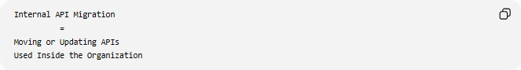
Internal API Migration
=
Moving or Updating APIs
Used Inside the Organization

📚 What is an Internal API?
# Source: AI Source: Provided by: [Data Path: Persons Table -> ID Column: 1, Name_En Column: Motasem Essam] -> From: [ChatGPT] on [6/7/2026]
An Internal API is an API that is only accessible within a company.
Examples:
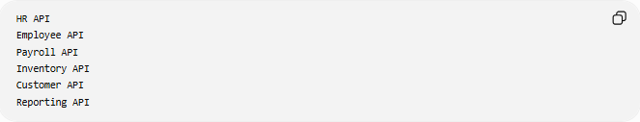
HR API
Employee API
Payroll API
Inventory API
Customer API
Reporting API
Used by:
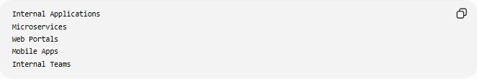
Internal Applications
Microservices
Web Portals
Mobile Apps
Internal Teams

🔍 Internal vs External APIs
# Source: AI Source: Provided by: [Data Path: Persons Table -> ID Column: 1, Name_En Column: Motasem Essam] -> From: [ChatGPT] on [6/7/2026]
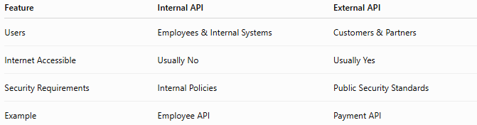
Feature | Internal API | External API
Users | Employees & Internal Systems | Customers & Partners
Internet Accessible | Usually No | Usually Yes
Security Requirements | Internal Policies | Public Security Standards
Example | Employee API | Payment API

Internal API Example
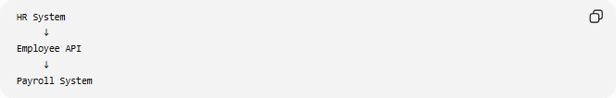
HR System
↓
Employee API
↓
Payroll System
Only company systems can access it.

🏗️ Common Internal API Migration Scenarios

1️⃣ Legacy API → Modern API
# Source: AI Source: Provided by: [Data Path: Persons Table -> ID Column: 1, Name_En Column: Motasem Essam] -> From: [ChatGPT] on [6/7/2026]
Before
Legacy Employee API

After
REST Employee API
Benefits:
Better Performance
Easier Maintenance

2️⃣ SOAP → REST
# Source: AI Source: Provided by: [Data Path: Persons Table -> ID Column: 1, Name_En Column: Motasem Essam] -> From: [ChatGPT] on [6/7/2026]
Before
Internal SOAP API

After
Internal REST API
Benefits:
JSON Support
Simpler Integration

3️⃣ Monolithic API → Microservices APIs
# Source: AI Source: Provided by: [Data Path: Persons Table -> ID Column: 1, Name_En Column: Motasem Essam] -> From: [ChatGPT] on [6/7/2026]
Before
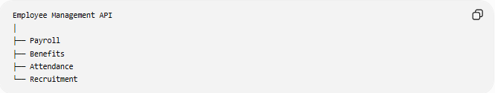
Employee Management API
│
├── Payroll
├── Benefits
├── Attendance
└── Recruitment

After
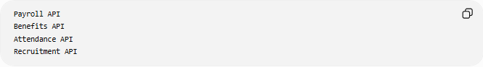
Payroll API
Benefits API
Attendance API
Recruitment API
Benefits:
Independent Deployment
Better Scalability

4️⃣ On-Prem API → Cloud API
# Source: AI Source: Provided by: [Data Path: Persons Table -> ID Column: 1, Name_En Column: Motasem Essam] -> From: [ChatGPT] on [6/7/2026]
Before
Data Center API

After
Cloud-Native API
Benefits:
Cloud Scalability
High Availability

🛠️ Real-World Example
# Source: AI Source: Provided by: [Data Path: Persons Table -> ID Column: 1, Name_En Column: Motasem Essam] -> From: [ChatGPT] on [6/7/2026]
Before Migration
A company uses an internal employee API.
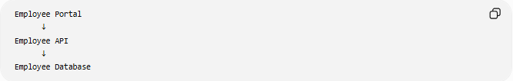
Employee Portal
↓
Employee API
↓
Employee Database
Problems:
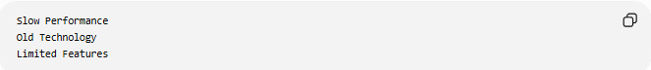
Slow Performance
Old Technology
Limited Features

Migration

Legacy Internal API
↓
Modern REST API

After Migration
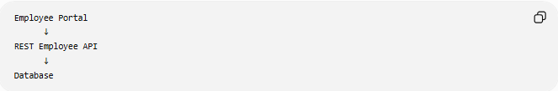
Employee Portal
↓
REST Employee API
↓
Database
Benefits:
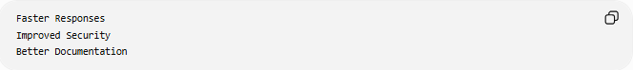
Faster Responses
Improved Security
Better Documentation

🔄 Internal API Migration Lifecycle
# Source: AI Source: Provided by: [Data Path: Persons Table -> ID Column: 1, Name_En Column: Motasem Essam] -> From: [ChatGPT] on [6/7/2026]
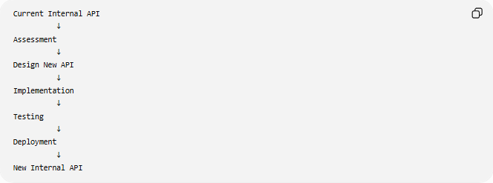
Current Internal API
↓
Assessment
↓
Design New API
↓
Implementation
↓
Testing
↓
Deployment
↓
New Internal API

📦 What May Change?
# Source: AI Source: Provided by: [Data Path: Persons Table -> ID Column: 1, Name_En Column: Motasem Essam] -> From: [ChatGPT] on [6/7/2026]
API Endpoints
Before
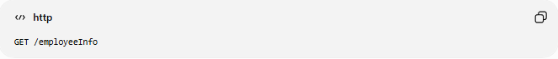
GET /employeeInfo

After

GET /employees/{id}

Authentication
Before
Basic Authentication

After
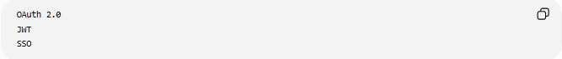
OAuth 2.0
JWT
SSO

Data Format
Before
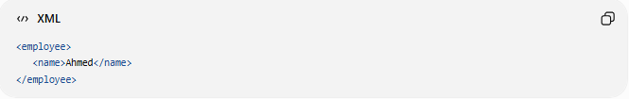2
<employee>
<name>Ahmed</name>
</employee>

After

{
"name": "Ahmed"
}

Architecture
Before
Monolithic API

After
Microservices APIs

🌍 Example Migration
# Source: AI Source: Provided by: [Data Path: Persons Table -> ID Column: 1, Name_En Column: Motasem Essam] -> From: [ChatGPT] on [6/7/2026]
Before
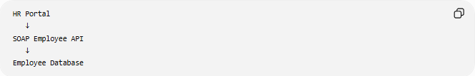
HR Portal
↓
SOAP Employee API
↓
Employee Database

After
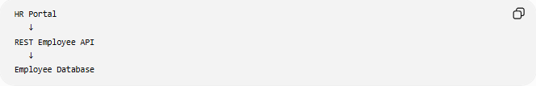
HR Portal
↓
REST Employee API
↓
Employee Database
Benefits:
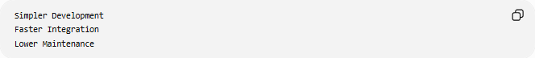
Simpler Development
Faster Integration
Lower Maintenance

⚠️ Common Challenges
# Source: AI Source: Provided by: [Data Path: Persons Table -> ID Column: 1, Name_En Column: Motasem Essam] -> From: [ChatGPT] on [6/7/2026]
Multiple Dependent Systems
Many applications may consume the same internal API.
Example:
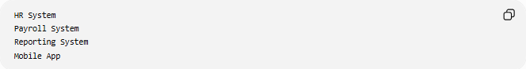
HR System
Payroll System
Reporting System
Mobile App
All must be updated.

Backward Compatibility
Older systems may still depend on the old API.

Data Consistency
All applications must receive the same business data after migration.

Security Updates
Authentication and authorization may need redesign.

Testing Complexity
Every dependent application must be validated.

✅ Benefits
# Source: AI Source: Provided by: [Data Path: Persons Table -> ID Column: 1, Name_En Column: Motasem Essam] -> From: [ChatGPT] on [6/7/2026]
Better Performance
Faster APIs
Optimized Queries

Improved Security
Modern Authentication
Better Access Control

Easier Maintenance
Cleaner Code
Modern Frameworks

Better Scalability
Handle More Users
Handle More Requests

Cloud Readiness
Cloud-Native Architecture

📊 Internal API Migration vs API Provider Migration
# Source: AI Source: Provided by: [Data Path: Persons Table -> ID Column: 1, Name_En Column: Motasem Essam] -> From: [ChatGPT] on [6/7/2026]
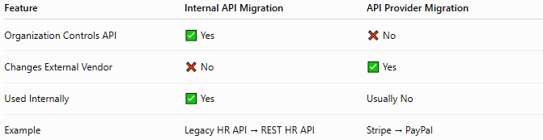
Feature | Internal API Migration | API Provider Migration
Organization Controls API | ✅ Yes | ❌ No
Changes External Vendor | ❌ No | ✅ Yes
Used Internally | ✅ Yes | Usually No
Example | Legacy HR API → REST HR API | Stripe → PayPal

Internal API Migration

Old Internal API
↓
New Internal API

API Provider Migration
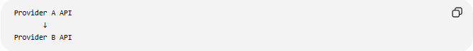
Provider A API
↓
Provider B API

🛠️ Common Technologies
# Source: AI Source: Provided by: [Data Path: Persons Table -> ID Column: 1, Name_En Column: Motasem Essam] -> From: [ChatGPT] on [6/7/2026]
API Styles
- REST
- SOAP
- GraphQL
Authentication
- OAuth 2.0
- JSON Web Token
API Management
- Kong Gateway
- Apigee

🧠 Simple Analogy
# Source: AI Source: Provided by: [Data Path: Persons Table -> ID Column: 1, Name_En Column: Motasem Essam] -> From: [ChatGPT] on [6/7/2026]
Imagine a company upgrades its internal phone system.
Before
Old Internal Phone Network

After
Modern Internal Communication System
Employees still communicate with each other, but the technology behind the system is newer and more efficient.
Internal API migration works similarly:

Old Internal API
↓
Modern Internal API
while continuing to serve the same internal business processes.

🧭 Summary
# Source: AI Source: Provided by: [Data Path: Persons Table -> ID Column: 1, Name_En Column: Motasem Essam] -> From: [ChatGPT] on [6/7/2026]
Internal API Migration is a type of API migration focused on APIs that are used exclusively inside an organization. It may involve upgrading API versions, changing authentication methods, moving from SOAP to REST, redesigning APIs into microservices, or migrating APIs to the cloud. The primary goals are improving performance, security, scalability, maintainability, and supporting modern application architectures while continuing to serve internal systems and teams.

